

**Contact**

**Send you Cv’s to** [**hr@mazco.com.sa**](mailto:hr@mazco.com.sa)

**Or**

**Post Box: 2486, Dammam 31451,**

**KINGDOM OF SAUDI ARABIA.**

**Tell: +966 3 8260080 EXT: 31**

**Fax : +966 3 8266618**

**Website::**[**www.mazco.com.sa**](http://www.mazco.com.sa)

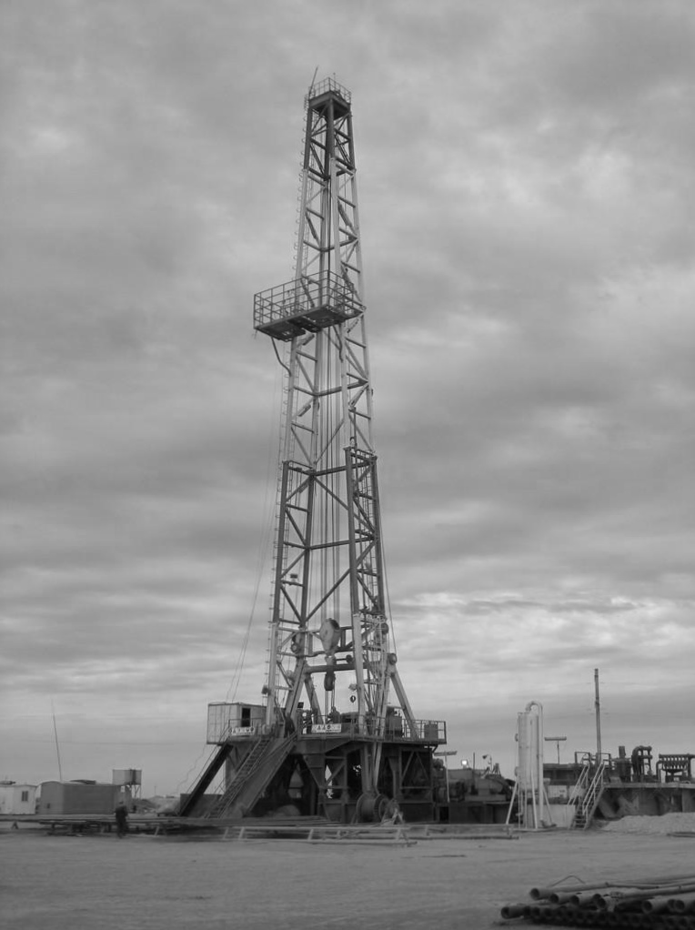

### **Job Specification:**

Assistant Driller shall:

* + - Monitor the repair of high pressure pump and associated valves, align mud system valves and transfer fluid from one pit to another.
    - Inspect safety lines ropes, air hoists, monkey board, derrick fingers, stabbing boards, sheaves, crown blocks, derrick bolts, pins, welds, and other equipment related to the derrick utilizing proper safety equipment, mixing drilling fluids and chemicals.
    - Monitor mud properties and perform calculations, recognize warning signs of kicks and stab casing from casing stabbing board.
    - Understand the purpose of blow-out prevention equipment and assist in nipping them up and down.
    - Perform as driller as and when required, act as lead hand when working on the rig floor, supervise personnel per driller instructions, train drill crew.
    - Identify and set priorities for the work, direct and coordinate crew members in performing the work, verify that appropriate tools and equipment are available and in working order at the appropriate time.
    - Use and store hand and power tools, handle drill string hoisting and rotating equipment.
    - Keep driller informed of needed operating supplies such as fuel, lubricants, mud and replacement parts for pumps and advise of unsafe conditions on the rig and in derrick.

### **Qualification:**

* + - Requires a comprehension of English to follow oral and written orders.
    - Have a minimum of eight years rotary rig experience, three of which as assistant driller.
    - Must be able to work at extreme heights without abnormal fears.
    - Familiar with drilling tools and equipment, drilling practices and procedures.
    - Must be holding a valid supervisory IWCF or Well Cap Well Control certificate.

Assistant Driller